**-HOW TO REGISTER**

Go to [www.seniorscollege.ca](http://www.seniorscollege.ca) and the following page appears.

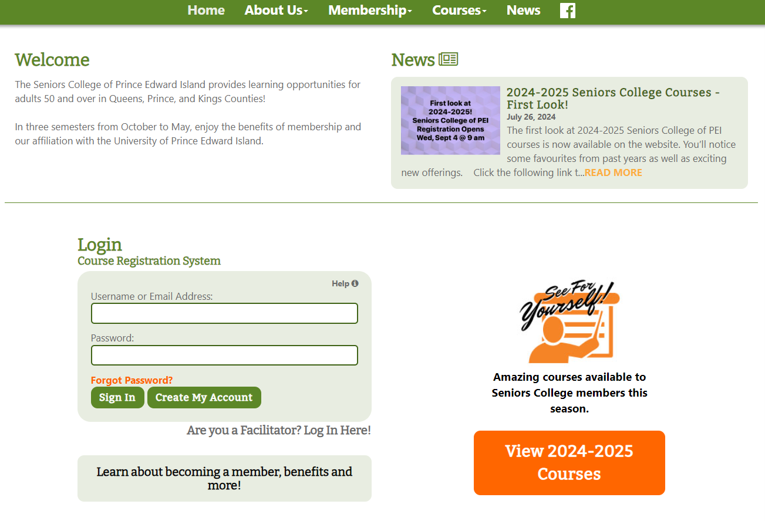

**Previous member**: Log in Already a Member. Your email address is your username. If you have forgotten your password, click on Forgot Password or email seniorscollege@upei.ca. Note that you can view courses without logging in by selecting **View 2024-2025 Courses**.

**New Member**: click **Create My Account**.

**After signing in, the following Member Home Page will appear.** Pay your annual Seniors College membership of $170 before registration by clicking on Account Status and follow the steps.

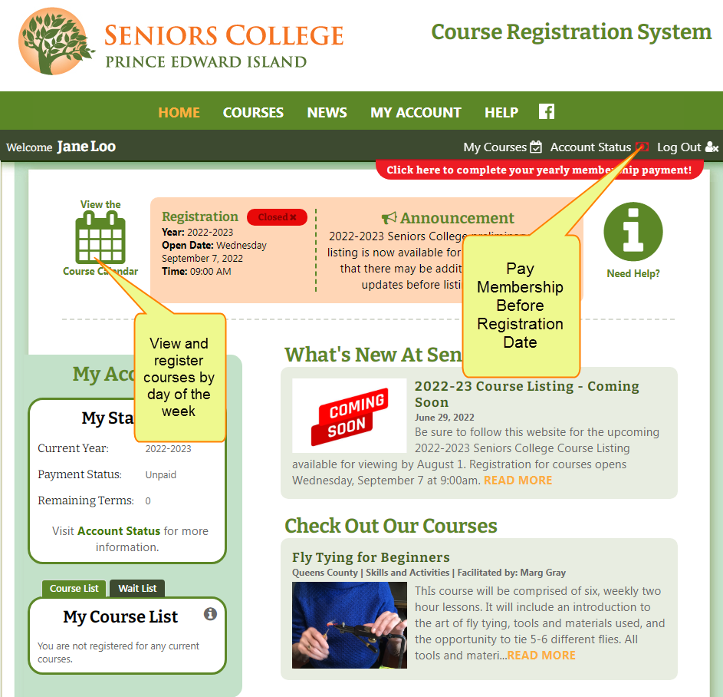

**Important Tip:** Pay membership before registration date because some courses fill quickly when registration Opens

Pay Membership

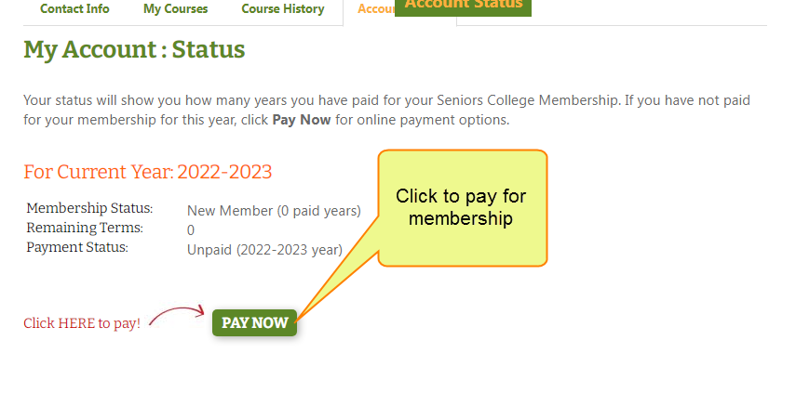

**Annual Membership of $170 permits members to register for multiple courses in the upcoming 3 terms.**

After clicking **Pay Now,** the next page is displayed.

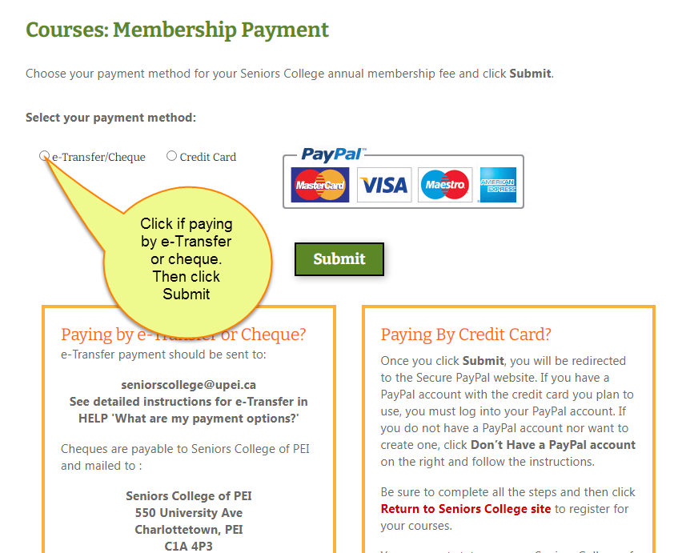

* **E-Transfer/Cheques must be sent to the above addresses within 10 days or your account will be cancelled**.
* **Paying by e-Transfer/Cheque**: Important to select e-Transfer/Cheque payment method to set your account to ‘Paid -payment pending’ and permit you to register before payment is received by Seniors College.
* **Include your member name** on e-Transfer/cheque information line.
* **Paying by credit card:** Use your PayPal account if you have one, create a Paypal account or use your credit card without a Paypal account. If the credit card you plan to use is already attached to a Paypal account, you must sign into your account.

**My Account: Status**

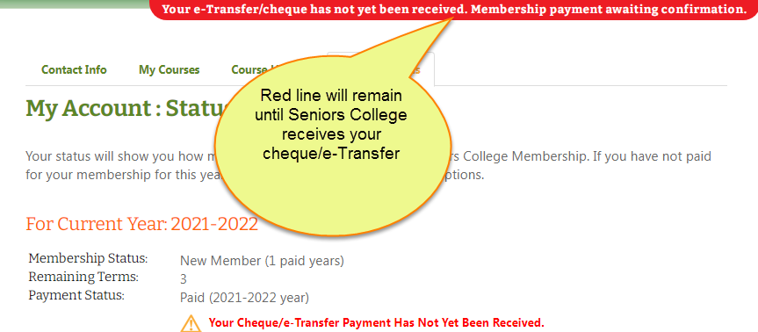

**Course List Legend – New Icons**

In addition to One Day Course and Additional Cost icons, two new icons in Legend identify Online and Hybrid courses.

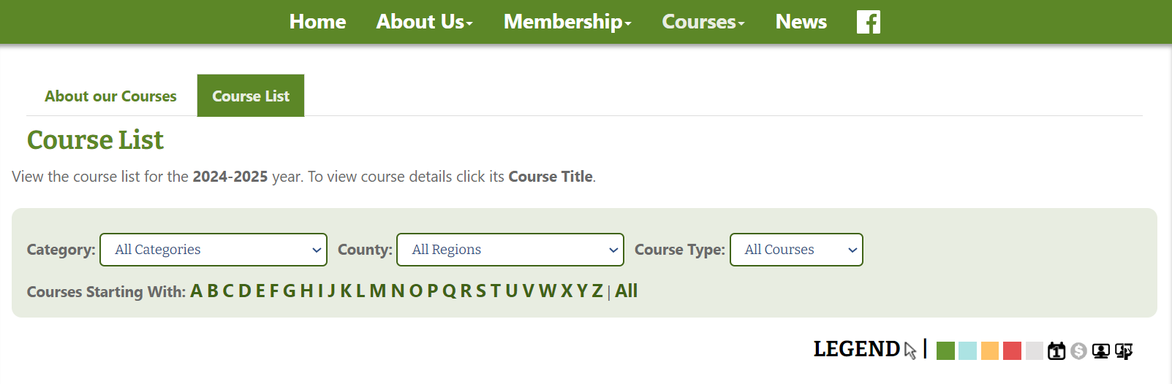

**Course is presented Online this term:**

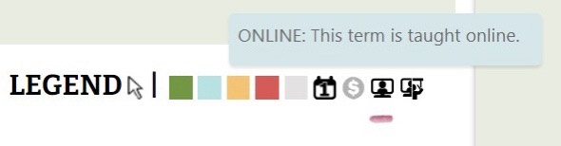

**Course is presented Online and In Person this term:**

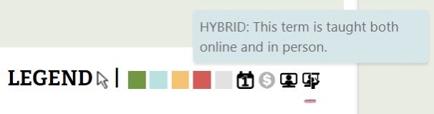

**Important note:** Some of the following screenshots show previous years; however, the instructions are correct.

View Courses by **Course List** (alphabetically) or **Course Calendar** (day of the week). Both options can be filtered by Category and County.

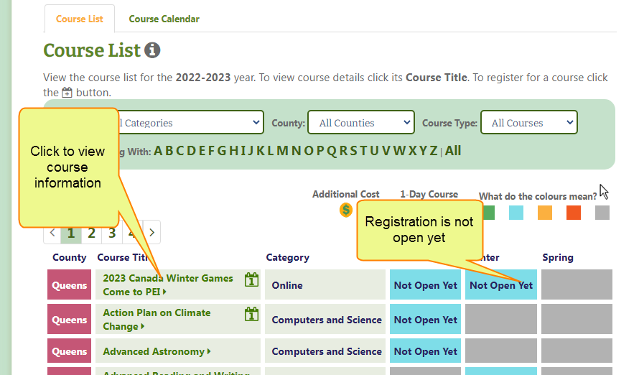

**Registration opens on September 4, 2024 at 9 am.** **Not Yet Open** will change to **Open**  **Click on it to Register**.

**Registering for courses**

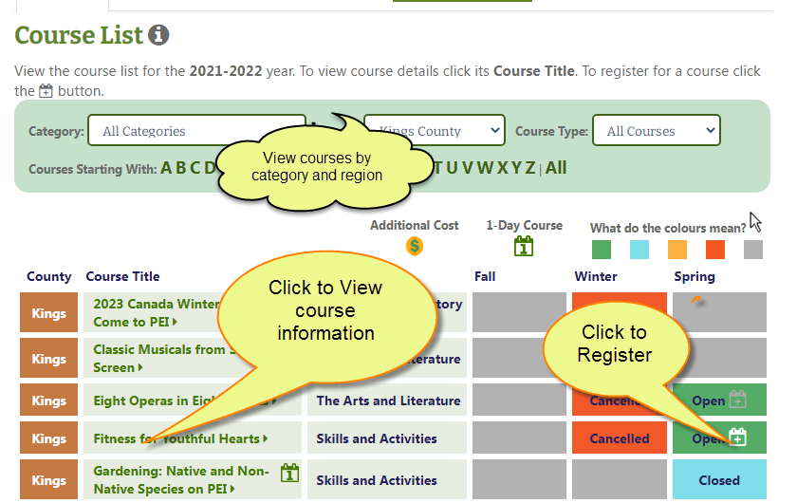

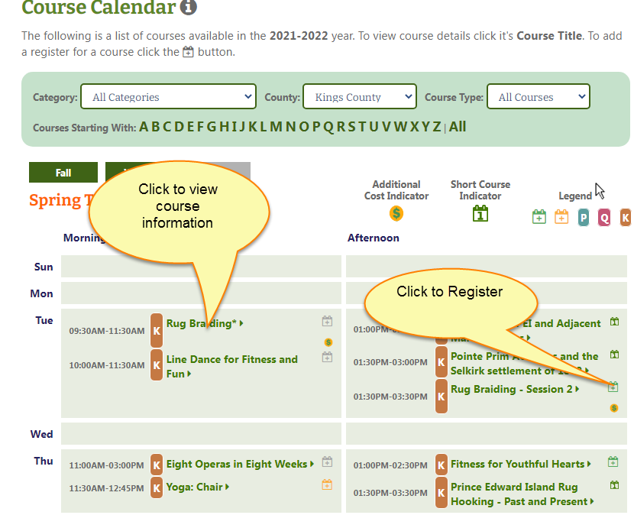

**To view, print or cancel your courses, go to My Account, My Courses**

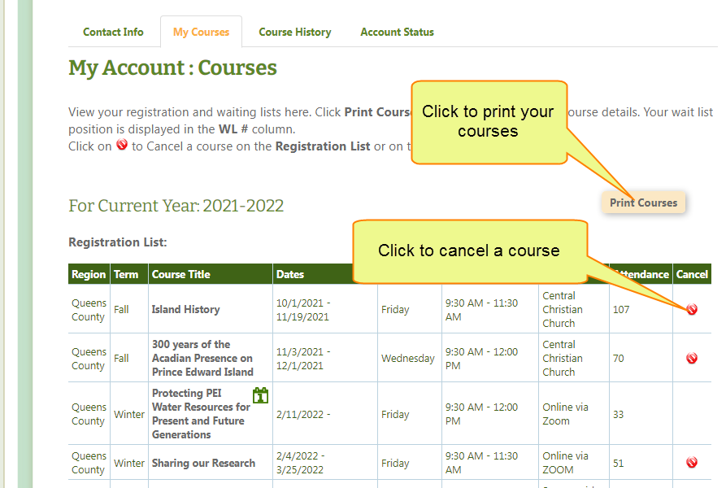

Change your password, email address or any information in your account by clicking My Account/Contact Info. It is important that your email address is up to date to receive information from Seniors College.

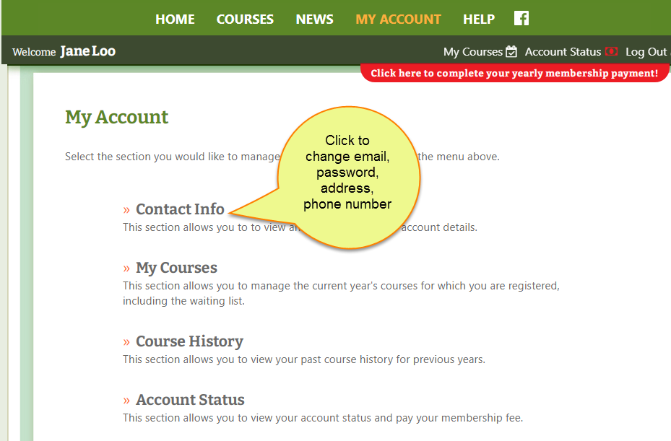

**Logout when finished.**